## Chapter 1

**INTRODUCTION**

* 1. **Introduction to Database Management System**

A database management system (DBMS) refers to the technology for creating and managing databases. DBMS is a software tool to organize (create, retrieve, update, and manage) data in a database. A software for storing and retrieving user by considering appropriate security measures. It allows users to create their own databases as per their requirement.

It consists of group of programs which manipulate the database and provide an interface between the database. It includes the user of the database and other application programs. The DBMS accepts the request for data from an application and instructs the operating system to provide the specific data. In large systems, a DBMS helps users and other third-party software to store and retrieve data.

If it is any field that has contributed to the greatest advancements in the world today, it is the field of information technology, commonly known by the acronym IT. When most people hear of the phrase ‘information technology’, they tend to picture several Tecno-geeks seated by the computer and fixing some computer software.

### 1.2 Types of DBMS

There are mainly 4 types of DBMS, which are Hierarchical, Relational, Network, and Object- Oriented DBMS.

* + - **Hierarchical DBMS:** As the name suggests, this type of DBMS has a style of predecessor-successor type of relationship. So it has a structure similar to that of a tree, wherein the nodes represent records and the branches of the tree represent fields.
    - **Relational DBMS (RDBMS**): This type of DBMS , uses a structure that allows the users to identify and access data in relation to another piece of data in the database.
    - **Network DBMS:** This type of DBMS supports many to many relations wherein multiple member records can be linked.
    - **Object-oriented DBMS:** This type of DBMS uses small individual software called objects. Each object contains a piece of data, and the instructions for the actions to be done with the data.

### 1.3 Applications of DBMS

1. **Railway Reservation System:** In the railway reservation system, the database is required to store the record or data of ticket bookings, status about train’s arrival, and departure. Also, if trains get late, people get to know it through database update.
2. **Library Management System:** There are lots of books in the library so; it is tough to store the record of all the books in a register or copy. So, the database management system (DBMS) is used to maintain all the information related to the name of the book, issue date, availability of the book, and its author.
3. **Banking:** Database management system is used to store the transaction information of the customer in the database.
4. **Education Sector:** Presently, examinations are conducted online by many colleges and universities. They manage all examination data through the database management system (DBMS). In spite that student’s registrations details, grades, courses, fee, attendance, results, etc. all the information is stored in the database.
5. **Credit card transactions:** Database Management system is used for purchasing on credit cards and generation of monthly statements.
6. **Social Media Sites:** We all use of social media websites to connect with friends and to share our views with the world. Daily, millions of peoples sign up for these social media accounts like Pinterest, Facebook, Twitter, and Google plus. By the use of the database management system, all the information of users are stored in the database and, we become able to connect with other people.
7. **Telecommunications:** Without DBMS any telecommunication company can’t think. The Database management system is necessary for these companies to store the call details and monthly postpaid bills in the database.
8. **Finance:** The database management system is used for storing information about sales, holding and purchases of financial instruments such as stocks and bonds in a database.
9. **Online Shopping:** Everyone wants to shop through online shopping websites (such as Amazon, Flipkart, snap deal) from home. So, all the products are sold and added only with the help of the database management system (DBMS). Invoice bills, payments, purchase information all of these are done with the help of DBMS.
10. **Human Resource Management:** Big firms or companies have many workers or employees working under them. They store information about employee’s salary, tax, and work with the help of database management system (DBMS).
11. **Manufacturing:** Manufacturing companies make different types of products and sale them on a daily basis. In order to keep the information about their products like bills, purchase of the product, quantity, supply chain management, database management system (DBMS) is used.
12. **Airline Reservation System:** This system is the same as the railway reservation system. This system also uses a database management system to store the records of flights departure, arrival, and delay status.

### Introduction to MySQL

MySQL is a Relational Database Management System (“RDBMS”). It is used by most modern websites and web-based services as a convenient and fast-access storage and retrieval solution for large volumes of data. MySQL is open-source and free software under the GNU license. It is supported by **Oracle Company**.

It is developed, marketed, and supported by **MySQL AB, a Swedish company**, and written in C programming language and C++ programming language. MySQL supports many Operating Systems like Windows, Linux, MacOS, etc. with C, C++, and Java languages.

MySQL can also be accessed using many tools. It can be easily communicated with via PHP (PHP Hypertext Preprocessor), a scripting language whose primary focus is to manipulate HTML for a webpage on the server before it is delivered to a client’s machine. A user can submit queries to a database via PHP, allowing insertion, retrieval and manipulation of information into/from the database.

MySQL server design is multi-layered with independent modules and is fully multithreaded by using

kernel threads. It can handle multiple CPUs if they are available. MySQL Server works in client/server

or embedded systems. and it works on many different platforms.

MySQL Command Syntax

The four main categories of SQL statements are as follows –

**DML (Data Manipulation Language)**

DML statements affect records in a table. These are basic operations we perform on data such as selecting a few records from a table, inserting new records, deleting unnecessary records, and updating/modifying existing records**.**

* SELECT – select records from a table

**SELECT column1, column2, ... FROM table_name;**

* INSERT – insert new records

**INSERT INTO table_name (column1, column2, column3, ...) VALUES (value1, value2, value3, ...);**

* UPDATE – update/Modify existing records

**UPDATE table_name**

**SET column1 = value1, column2 = value2, ... WHERE condition;**

* DELETE – delete existing records

**DELETE FROM table_name WHERE condition; DDL (Data Definition Language)**

DDL statements are used to alter/modify a database or table structure and schema. These statements handle the design and storage of database objects.

* CREATE – create a new Table, database, schema

**CREATE TABLE table_name (**

**column1 datatype, column2 datatype, column3 datatype,**

**....**

**);**

* ALTER – alter existing table, column description

**ALTER TABLE table_name ADD column_name datatype;**

* DROP – delete existing objects from database

**DROP TABLE table_name; DCL (Data Control Language)**

DCL statements control the level of access that users have on database objects.

* GRANT – allows users to read/write on certain database objects

**mysql> GRANT ALL PRIVILEGES ON database_name.* TO 'username'@'localhost';**

* REVOKE – keeps users from read/write permission on database objects

**REVOKE privileges ON object FROM user;**

### TCL (Transaction Control Language)

TCL statements allow you to control and manage transactions to maintain the integrity of data within SQL statements.

* BEGIN Transaction – opens a transaction

**[begin_label:] BEGIN [statement_list]**

**END [end_label]**

* COMMIT Transaction – commits a transaction

**COMMIT [ { TRAN | TRANSACTION } [ transaction_name | @tran_name_variable ] ] [ WITH ( DELAYED_DURABILITY = { OFF | ON } ) ]**

**[ ; ]**

* ROLLBACK Transaction – ROLLBACK a transaction in case of any error

**ROLLBACK { TRAN | TRANSACTION }**

**[ transaction_name | @tran_name_variable**

**| savepoint_name | @savepoint_variable ] [ ; ]**

**Chapter 2**

**ANALYSIS AND REQUIREMENT SPECIFICATION**

### Purpose of this project

The Student Details and GPA Management System is a comprehensive platform designed to streamline academic processes within an educational institution. It offers administrative personnel robust control over student records and grade management, ensuring data security and accuracy. Registered students can conveniently access their academic information, manage course enrollments, and track their GPA. By centralizing data management and automating administrative tasks, the system enhances efficiency, supports better student progress tracking, and contributes to creating an optimal learning environment.

The Student GPA Management System requirements are as follows:

* + - Store details of newly enrolled students.
    - Assist administrators in managing and retrieving student information efficiently.
    - Enable updating and deletion of student records.
    - Fulfill user needs for tracking GPA, course grades, and academic progress.
    - Provide a user-friendly interface for students and administrators.
    - Ensure timely processing of GPA calculations and grade updates according to the academic

schedule.

### 2.3 Scope of this project

The Student GPA Management System project aims to streamline the process of managing student

academic records and calculating their Grade Point Averages (GPAs). It provides a user-friendly

platform for students to input their course grades and track their academic progress efficiently.

The system allows students to access their GPA information and course history easily, enhancing transparency and convenience.

• Students can input their course grades and credits directly into the system, eliminating

the need for manual record-keeping and reducing errors.

•The system calculates GPAs automatically based on the entered grades and credits,

providing accurate and up-to-date academic performance indicators.

•Students can generate GPA reports and transcripts from the system, enabling them to

monitor their progress and plan their academic goals effectively.

•It promotes a secure and confidential environment by ensuring that student information is kept

private and not shared with unauthorized parties.

By leveraging technology, the Student GPA Management System simplifies GPA tracking and

enhances the overall student experience, saving time and effort for both students and academic administrators.

### 2.3 Functional Requirements

**Modules:**

* + - Student details Management Module: Used for managing the student details.
    - Faculty Module: Used to Manage information About student .
    - Student Module: Used To Give Information About Authors.
    - Student Login Module: Used for managing the student information.
    - Faculty Login Module: Used for managing the login details.
    - Registering GPA information Module: Used to Give Information About GPA.
    - Registering Branch information Module: Used to Give Information About Branch.
    - Registering Enrollment information Module: Used To give information about Enrollment of student to branches

### 2.4 Non-Functional Requirements

* + 1. **Software requirements**
       - Operating System : Windows 11
       - Software :XAMPP
       - Front-End : HTML, CSS, JAVASCRIPT,PHP
       - Back-End : MYSQL
    2. **Hardware requirements**
* Processor Name :10th Gen Intel® Core™ i3-1115G4
* Processor Speed :4.10 GHz
* System Type :64-bit OS, x64-based processor
* RAM :8GB
  + 1. **Hard drive specification**
* Pen drive : SanDisk
* Storage : 256 GB

**Chapter 3**

**DESIGN**

**3.1 ER Diagram**

ER model stands for an Entity-Relationship model. It is a high-level data model. This model is used to define the data elements and relationship for a specified system. It develops a conceptual design for the database. It also develops a very simple and easy to design view of data. In ER modelling, the database structure is portrayed as a diagram called ER-Radiogram.

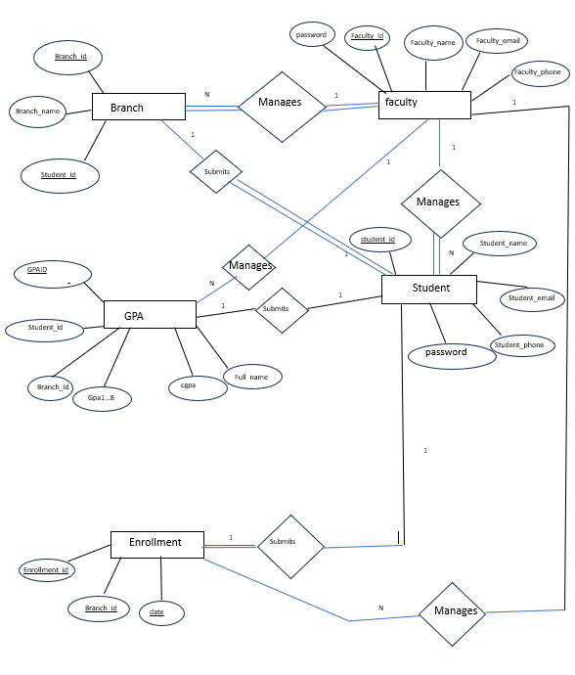

Fig 3.1 ER diagram of library database

### Schema Diagram

A database schema is a structure that represents the logical storage of the data in a database. It describes both the organization of data and the relationships between tables in a given database. A database schema contains schema objects that may include tables, fields, packages, views, relationships, primary key, foreign key.

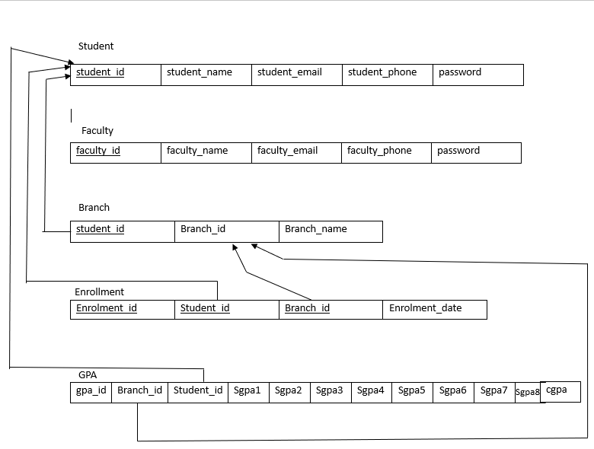

Fig 3.2 Schema diagram of library database

## Chapter 4

**IMPLEMENTATION**

### 4.1 Implementation of Table Creation page

Table implementation for Student details and GPA Management System has been done under the library database using MySQL create table queries. It includes 5 tables, one for Student login and registration, Faculty table, GPA details, Branch Details, Student Enroll Details .The attribute in Student Login table is the key and acts as foreign key in all other tables.

### Implementation of Table Insertion page

The visual aspects of the website that can be seen and experienced by users are frontend. On the other hand, everything that happens in the background can be attributed to the backend.

Languages used for the front end are HTML, CSS. In the front we designed in such way manner, where user can upload the image of things to sell or they can select the item for buy. Here we have information regarding website developer and footer where user can connect with the developer.

### Implementation of Student detail page

We have created a Book detail page in HTML and CSS for our Student Details and GPA website. A single page is used for Faculty when we want to display the details of any Students. It has all the necessary information about that particular Student. All of these things are created with the help of HTML and CSS.

After that, we have the Details of Students in menu. Then we have a Login, logout, Student Signup. These boxes are created using a div tag. By using the div tag we can put all the things inside the div and then we can design them using CSS.

### Implementation of Designs

My website is a testament to minimalist design, where every element serves a purpose without relying on any images. Crafted solely with HTML and CSS, it embodies simplicity and efficiency. Through clever coding and layout, the website delivers a seamless user experience, emphasizing content over flashy visuals. Text, shapes, and colors harmonize to convey information effectively and aesthetically. By eschewing images, the site prioritizes accessibility, ensuring swift loading times and compatibility across devices. Its clean lines and crisp typography create a modern, sleek appearance that captivates visitors while emphasizing the power of pure code in web design.

* 1. **Implementation of Place order page**

We have used input tags to enter the type of “query”, “name”, “email-id”, “phone number” and many more of the query. The student has to enter their personal details as mentioned along with pin code and state.

* 1. **Implementation of Trigger**

The implementation of triggers in our student database involves creating automated actions that respond to certain events or conditions in the database. For instance, we could create a trigger to update the total number of available student details whenever new details are added. This trigger would execute a specific SQL statement or set of statements whenever the designated event occurs. By defining triggers, we can enforce data integrity, automate routine tasks, and maintain consistency in our student database without manual intervention**.**

INSERT INTO logs (null, NEW.usn,” Inserted”, NOW ());

* 1. **Implementation of Stored Procedures**

The implementation of stored procedures in our student database entails creating pre-defined sets

of SQL statements that perform specific tasks or operations. For example, we could create a stored

procedure to handle the process of deleting of details, which would involve updating the status

of the student details, recording the information, and updating relevant tables to reflect the transaction. These stored procedures can encapsulate complex logic and business rules, promoting

code reusability, enhancing security, and improving database performance.

SELECT * FROM student;

## Chapter 5

### SNAPSHOTS

**5.1 Screen shots**

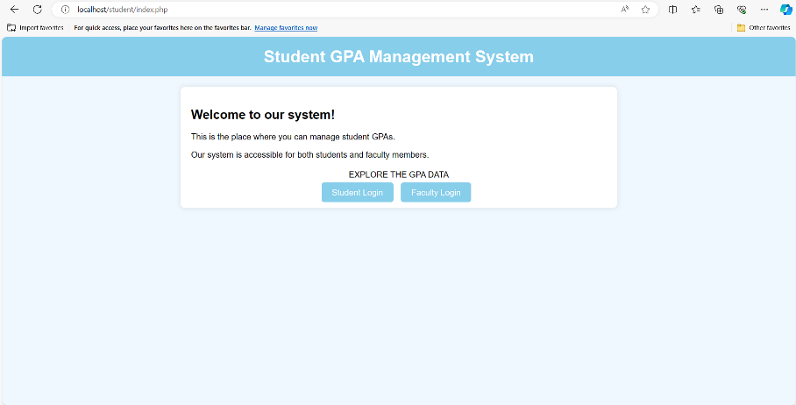

Fig 5.1 Screen shot of showing Project home page

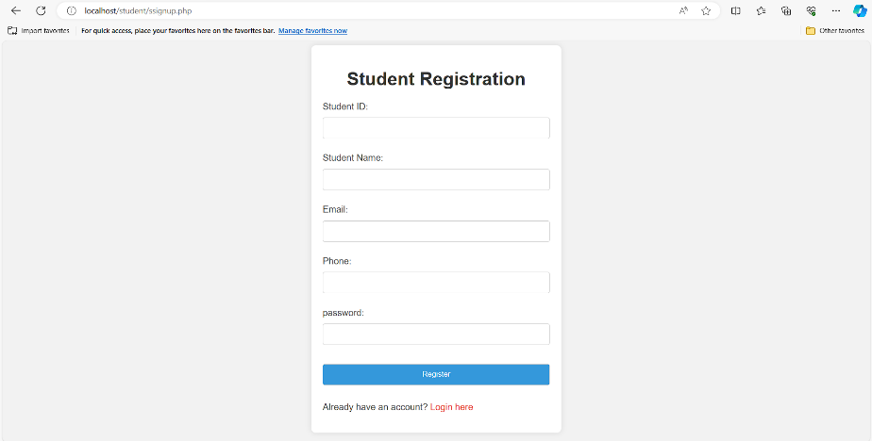

Fig 5.2 Screen shot of showing Student signup page

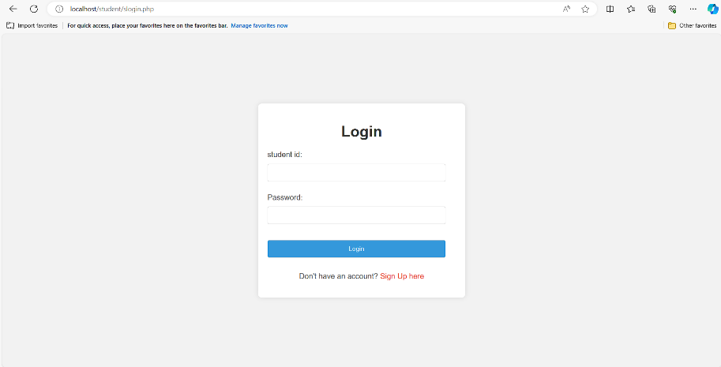

Fig 5.3 Screen shot of showing Student login page

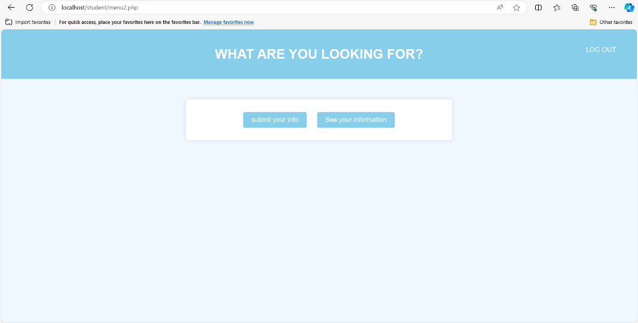

Fig 5.4 Screen shot of showing Menu for students

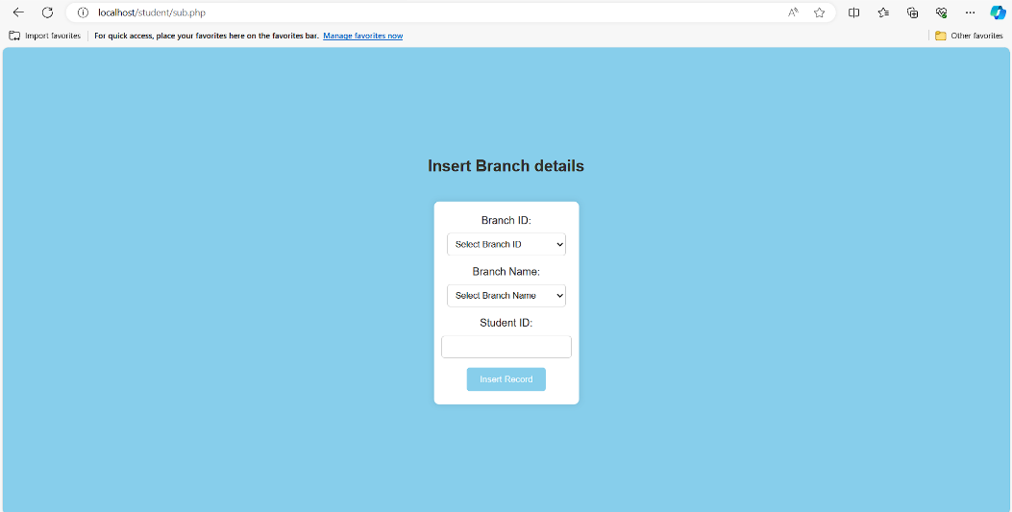

Fig 5.5 Screen shot of showing Insert Branch details

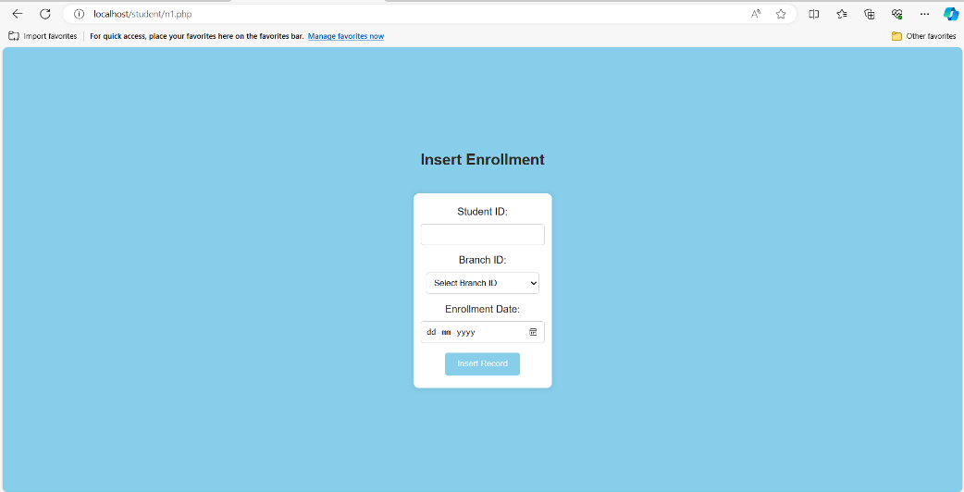

Fig 5.6 Screen shot of showing Insert details of Enrolment

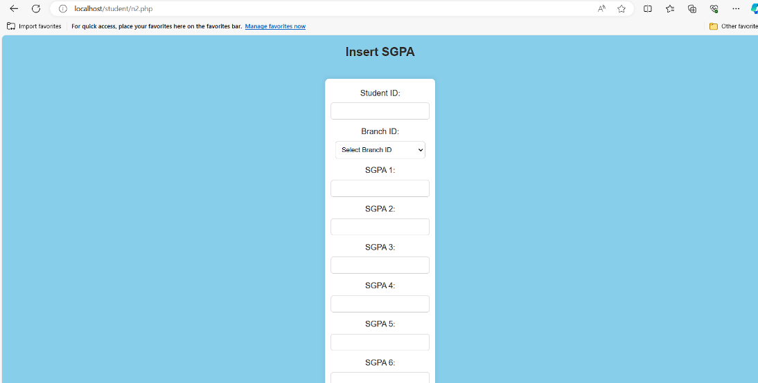

Fig 5.7 Screen shot of showing Insert SGPA details

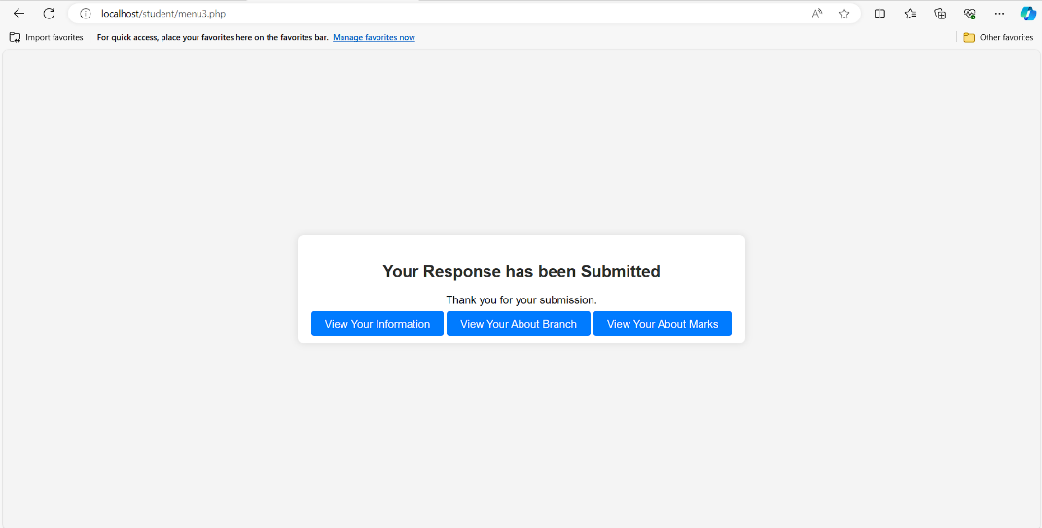

Fig 5.8 Screen shot of showing to view Responses

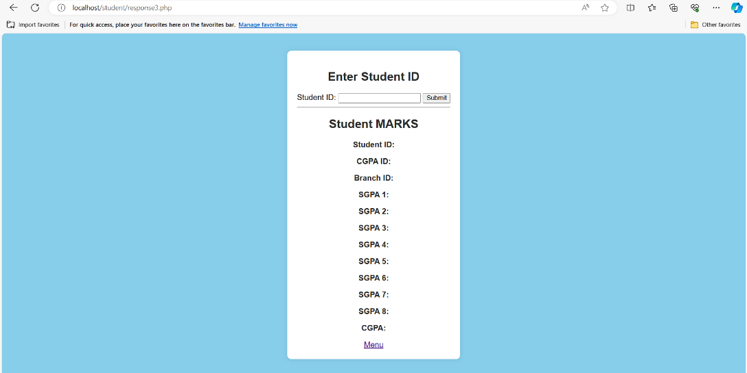

Fig 5.9 Screen shot of showing SGPA details

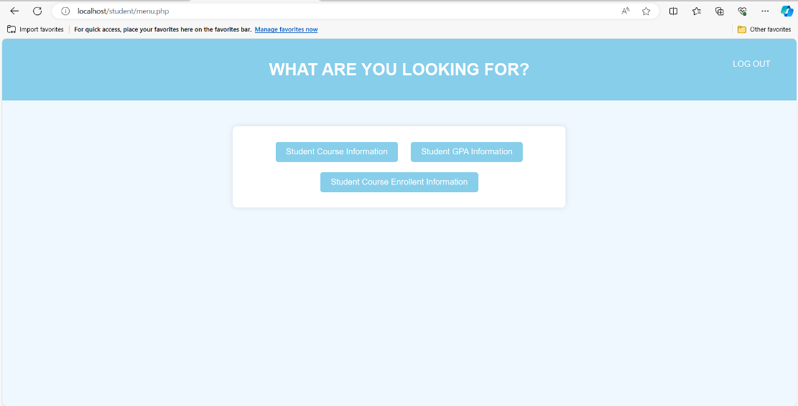

Fig 5.10 Screen shot of showing menu for Faculty of particular student

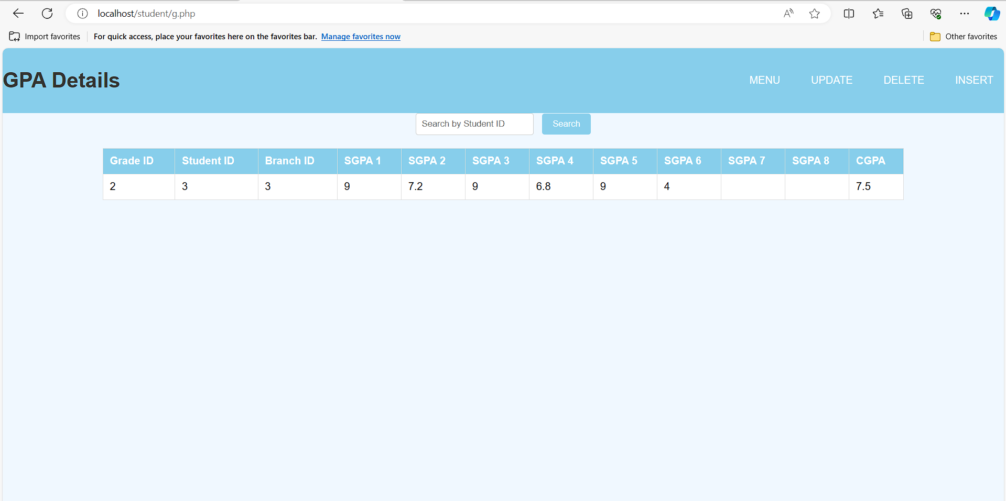

Fig 5.11 Screen shot of showing GPA details

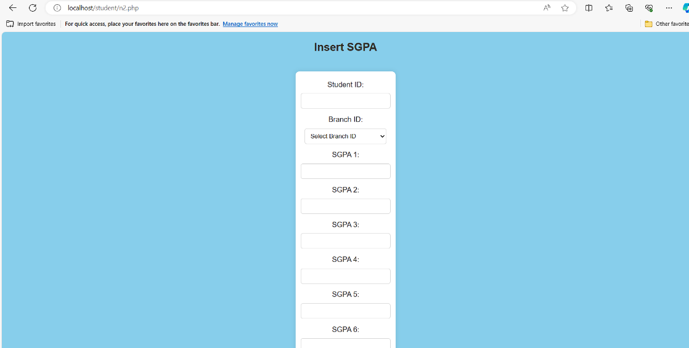

Fig 5.12 Screen shot of showing insert details for faculty

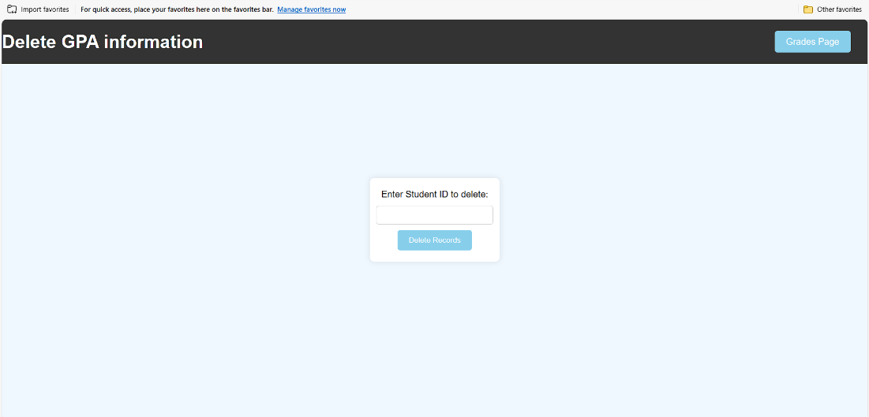

Fig 5.13 Screen shot of showing delete GPA information

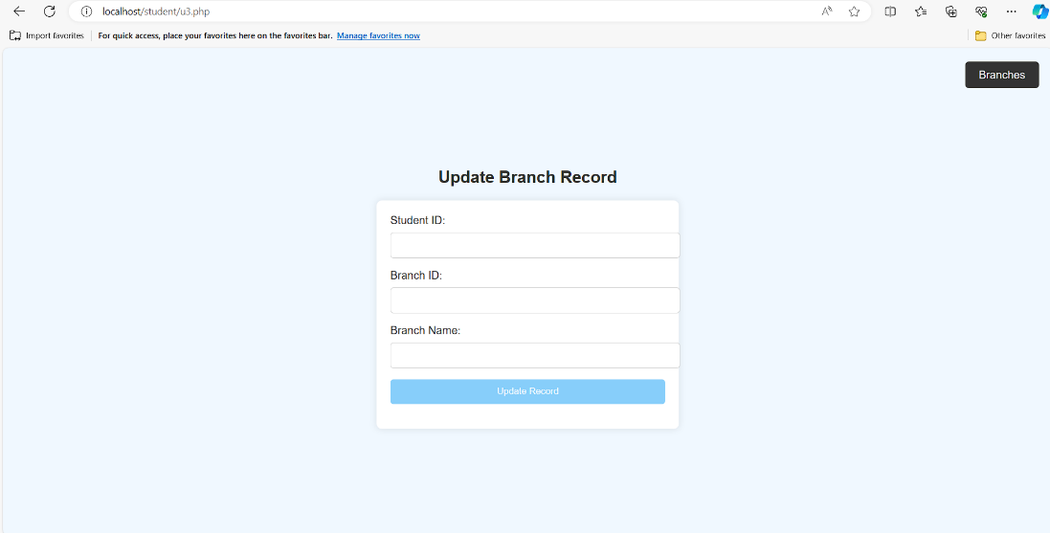

Fig 5.13 Screen shot of showing Update Branch Record

## CHAPTER 6

**CONCLUSION**

In conclusion, database management systems (DBMS) play a crucial role in various sectors such as education, finance, telecommunications, and more, by efficiently organizing and managing data. MySQL, as a relational database management system, offers a robust solution for storing and retrieving data, supporting modern websites and web-based services. With its comprehensive command syntax and functionality, MySQL facilitates the implementation of projects like the one outlined here, which aims to streamline processes and enhance user experiences.

## REFERENCES

[1] Fundamentals of Database Systems, Ramez Elmasri and Shamkant B. Navathe, 7th Edition, 2017, Pearson.

[2] Database management systems, Ramakrishnan, and Gehrke, 3rd Edition, 2014, McGraw Hill.

[3] Abraham Silberschartz, Henry F.Korth and S.Sudarshan’s Database System Concepts 6th Edition Tata

Mcgraw Hill Education Private Limited.